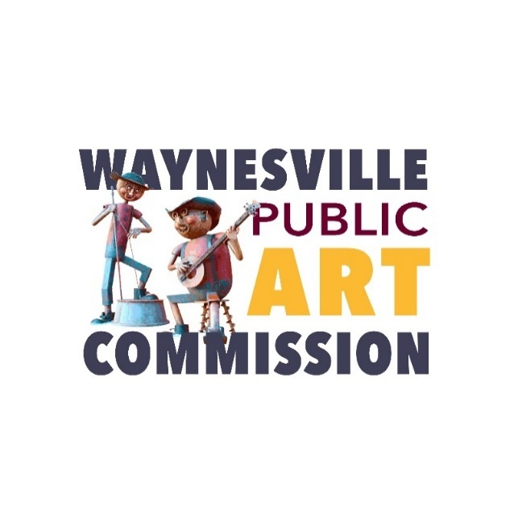

***Mission Statement: The mission of the Waynesville Public Art Commission is to engage the community and enrich public spaces through original art that celebrates Waynesville’s historic, cultural, natural and human resources.***

**AGENDA: Regular Scheduled Meeting**

June 13, 2024

Thursday, 4:00 p.m.

16 S. Main Street

Waynesville, NC 28786

Call to Order – Chairman George Kenney

1. Adoption of minutes from the May 9, 2024 regular meeting
2. Chefs on Fire Logistics and Discussion
3. Pigeon Community Installation Discussion
4. Other Business

The next Public Art Commission meeting: **July 11, 2024**